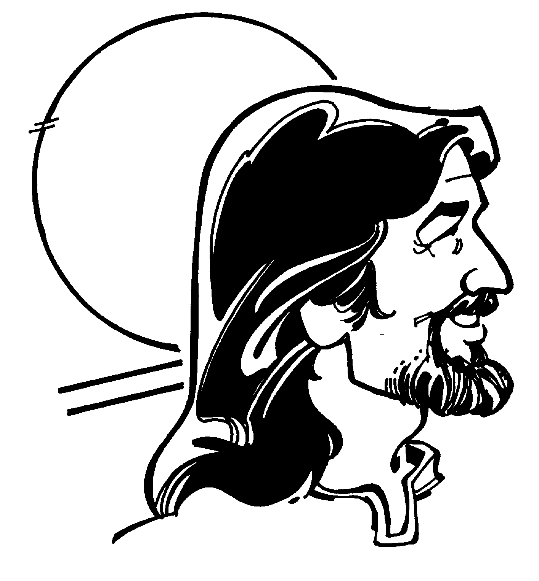
Christ Alone

October 28, 2012
There are many different religions in the world, and many people believe that they all lead to the same God in the end. However, they are not the same. They say different, contradictory things. Furthermore, Jesus predicted that there would arise many false prophets and false teachers who would lead people astray, not lead them to God. Jesus is the only one who has died for our sins and rose from the dead for us. We Lutherans declare, in accordance with the Bible, that Jesus is the only way of salvation, the only way to God. (John 14:6)

Opening Hymn: In Christ Alone
In Christ alone my hope is found, He is my light, my strength, my song.
This Cornerstone, this solid ground, firm through the fiercest drought and storm.
What heights of love, what depths of peace, when fears are stilled, when strivings cease!
My Comforter, my all in all, here in the love of Christ I stand.

In Christ alone, who took on flesh, fullness of God in helpless Babe.
This gift of love and righteousness scorned by the ones He came to save.
‘Til on that cross as Jesus died the wrath of God was satisfied;
For ev’ry sin on Him was laid. Here in the death of Christ I live.

There in the ground His body lay, Light of the world by darkness slain.
Then bursting forth in glorious day, up from the grave He rose again!
And as He stands in victory, sin’s curse has lost its grip on me.
For I am His and He is mine, bought with the precious blood of Christ.

No guilt in life, no fear in death, this is the pow’r of Christ in me.
From life’s first cry to final breath, Jesus commands my destiny.
No pow’r of hell, no scheme of man can ever pluck me from His hand.
‘Til He returns or calls me home, here in the pow’r of Christ I’ll stand.

(If you don’t know this hymn, you can sing “Rock of Ages”, LSB 761)

Invocation
Leader: In the name of the Father and of the Son and of the Holy Spirit.
Congregation: Amen.
L: You have come to Jesus, the living Stone,
C: Rejected by men but chosen by God.
L: God says, “See, I lay a Stone in Zion, a chosen and precious cornerstone,
C: And the one who trusts in him will never be put to shame.
L: Now to you who believe, this stone is precious.
C: But to those who do not believe, he is a “stone that causes men to stumble, and a rock that makes them fall.” (1 Peter 2:4-8, selected portions)

Confession
L: Brothers and sisters in Christ, we all often stumble. Our hearts love to stray from God’s ways. Now, at the beginning of our worship, it is appropriate that we acknowledge what we have done wrong and to ask God for forgiveness.
Personal Prayer of Confession: We take a few moments to reflect and to pray to the Lord in silence.
Collective Prayer of Confession: (responsively)
L: Lord Jesus, forgive us, for we have not followed you as we should.
C: We call you the Way, but we often go astray.
L: We call you the Truth, but we often don’t take time to listen to you.
C: We call you the Life, but we don’t rejoice in you.
L: We call you the Light, but we often love the darkness.
C: We call you Master, but we don’t do what you say.
L: We call you Lord, but we don’t serve you with our whole heart.
C: We call you Almighty, but we don’t trust you in times of trouble.
L: We call you Just, but we don’t fear your anger enough to change our habits.
C: We call you Love, but we don’t show that love in our lives.
L: For these and other failures, forgive us, Lord Jesus.
C: Cleanse us and make us new in your name.

Song of Repentance (Just As I Am, LSB 570, v. 1 and 5)
Just as I am, without one plea,
But that thy blood was shed for me
And that thou bidd’st me come to thee,
Oh Lamb of God, I come, I come.

Just as I am, thou wilt receive,
Wilt welcome, pardon, cleanse, relieve,
Because thy promise I believe,
Oh Lamb of God, I come, I come.

Promise of Forgiveness
All: This is how God showed his love among us: he sent his one and only Son into the world that we might live through him. This is love: not that we loved God, but that he loved us and sent his Son as an atoning sacrifice for our sins. (1 John 4:9-10)
Leader: Jesus is our Rock! He died on the cross in our place, paying the price for our failures. Scripture promises that "if you confess with your mouth that Jesus is Lord and believe in your heart that God raised Him from the dead, you will be saved." Romans 8:9 I therefore proclaim to you by God’s authority, what he says here in his Word: all your wrongdoing and failures are forgiven, in the name of the Father and of the Son and of the Holy Spirit.
Cong.: Amen.

Responsive Reading: (1 Timothy 2:4-6, Acts 4:11-12, Psalm 18:31)
(Selected portions)
L: God our Savior… wants all men to be saved
C: And to come to a knowledge of the truth.
L: Christ Jesus… gave himself as a ransom for all men -
C: The testimony given in its proper time.
L: This Jesus is “the stone you builders rejected,
C: Which has become the capstone.”
L: Salvation is found in no one else,
C: For there is no other name under heaven given to men by which we must be saved.
L: Who is God besides the Lord?
C: Who is the Rock except our God?

Hymn: Beautiful Savior (LSB 537)

Readings from the Bible
Old Testament Deuteronomy 4:32-40
(The Lord is God, and there is no other.)
Ask now about the former days, long before your time, from the day God created human beings on the earth; ask from one end of the heavens to the other. Has anything so great as this ever happened, or has anything like it ever been heard of? ³³ Has any other people heard the voice of God speaking out of fire, as you have, and lived? ³⁴ Has any god ever tried to take for himself one nation out of another nation, by testings, by signs and wonders, by war, by a mighty hand and an outstretched arm, or by great and awesome deeds, like all the things the Lord your God did for you in Egypt before your very eyes?
³⁵ You were shown these things so that you might know that the Lord is God; besides him there is no other. ³⁶ From heaven he made you hear his voice to discipline you. On earth he showed you his great fire, and you heard his words from out of the fire. ³⁷ Because he loved your ancestors and chose their descendants after them, he brought you out of Egypt by his Presence and his great strength, ³⁸ to drive out before you nations greater and stronger than you and to bring you into their land to give it to you for your inheritance, as it is today.
³⁹ Acknowledge and take to heart this day that the Lord is God in heaven above and on the earth below. There is no other. ⁴⁰ Keep his decrees and commands, which I am giving you today, so that it may go well with you and your children after you and that you may live long in the land the Lord your God gives you for all time.
New Testament 1 John 4:1-6
(Don’t be misled; the true Spirit of God confesses Jesus Christ as Savior.)
Dear friends, do not believe every spirit, but test the spirits to see whether they are from God, because many false prophets have gone out into the world. ² This is how you can recognize the Spirit of God: Every spirit that acknowledges that Jesus Christ has come in the flesh is from God, ³ but every spirit that does not acknowledge Jesus is not from God. This is the spirit of the antichrist, which you have heard is coming and even now is already in the world.
⁴ You, dear children, are from God and have overcome them, because the one who is in you is greater than the one who is in the world. ⁵ They are from the world and therefore speak from the viewpoint of the world, and the world listens to them. ⁶ We are from God, and whoever knows God listens to us; but whoever is not from God does not listen to us. This is how we recognize the Spirit of truth and the spirit of falsehood.
Holy Gospel John 14:1-6
(Jesus is the only way to the Father.)
“Do not let your hearts be troubled. You believe in God^{[a]}; believe also in me. ² My Father’s house has many rooms; if that were not so, would I have told you that I am going there to prepare a place for you? ³ And if I go and prepare a place for you, I will come back and take you to be with me that you also may be where I am. ⁴ You know the way to the place where I am going.”
⁵ Thomas said to him, “Lord, we don’t know where you are going, so how can we know the way?” ⁶ Jesus answered, “I am the way and the truth and the life. No one comes to the Father except through me.

Hymn: My Hope is Built on Nothing Less (LSB 575 or 576)

Sermon

Hymn: Oh For a Thousand Tongues to Sing (LSB 528)

A Response of Faith: Declaration of Faith (taken from the Catechism)
Together we declare what we believe, using words from the Catechism:
I believe that Jesus Christ, true god, begotten of the Father from eternity, and also true man, born of the virgin Mary, is my Lord. He has redeemed me, a lost and condemned person. He purchased and won me from all sins, from death, and from the power of the devil, not with gold or silver, but with his holy, precious blood and with his innocent suffering and death. He did this that I may be his own and live under him in his kingdom and serve him in everlasting righteousness, innocence, and blessedness, just as he is risen from the dead, lives, and reigns to all eternity. This is most certainly true. Amen.

A Response of Faith: the Offering
If you are visiting today for the first time, you are our guest, and you do not need to give an offering unless the Lord lays that on your heart. For those who are members or faithful friends of the congregation, our offerings sustain the mission and ministry of Faith Lutheran Church. Our offerings are a significant part of our worship, a response of love to God who has given us so much.
The Bible says this: “Each person should give what he has decided in his heart to give, not reluctantly or under compulsion, for God loves a cheerful giver. And God is able to make all grace abound to you, so that in all things at all times, having all that you need, you will abound in every good work.” (2 Corinthians 9:7-8)

A Response of Faith: Prayer of Dedication
All: Lord, these offerings are just a small part of what you have given us. Bless these resources for the mission of your Church, and help us to use everything you have given us in faith and love, according to your will. In Jesus’ name. Amen.

A Response of Faith: Prayers of the Congregation
L: Almighty God, we thank you for all the things you have done for us. We have done nothing to deserve your goodness. Nevertheless, you have given us your love. You have provided food, clothing, shelter, and so many other things. And most of all, you have given us forgiveness and the promise of eternal life through Jesus Christ. Thank you for all of your blessings! Lord, in your mercy.
C: Hear our prayer.
L: Lord, you are our King, and you are the rightful ruler over all the world. Watch over our nation. Protect us, that we may live securely in peace and may have freedom to proclaim your message of salvation. Guide the president and everyone in authority so that they may know your will and put it into practice. Watch over our soldiers and police and all who risk their lives in service. Halt injustice and oppression and bring to repentance those who stray from your ways. Lord, in your mercy.
C: Hear our prayer.
L: Heavenly Father, extend your mercy to all the people of the world who do not have hope in Jesus Christ. Touch their hearts and turn them to you. Raise up faithful pastors and missionaries and teachers and leaders in your church, and use them to equip all of us to share the message of salvation with everyone around us. Lord, in your mercy.
C: Hear our prayer.
L: Lord Jesus, you are the great Physician of body and soul. We ask you to hear our prayers for those who are ill, especially ____________. Comfort them, Lord, and restore them to health according to your will, so that they may praise your name and serve you with all their strength. Lord, in your mercy.
C: Hear our prayer.
L: Lord God, we lift up to you all those who are in trouble, or who are lonely, or who have problems at home or at work or in any other place, or who are hungry or without work or need help. We know that you love us and you ask us to place all our needs in your hands. Help us to trust in you and lead us to the solutions and the help that we need. Lord, in your mercy,
C: Hear our prayer.
Other prayers may be added. Particularly, if there is a special occasion:
L: Lord God, we thank you for our friends and family, and for the love they bring to our lives. Bless _______________ on their anniversary, and bless _____________ on his/her birthday. Thank you for bringing them through another year. Be with them as they celebrate, and continue to protect them and guide them in the years ahead. Lord, in your mercy,
C: Hear our prayer.
L: Heavenly Father, thank you for the life of this newborn child, _________. Help us to show your love to him/her. Let him/her grow up trusting in you and following you with all his/her heart. Protect him/her and guide him/her throughout his/her time on this earth. Lord, in your mercy.
C: Hear our prayer.
L: Lord God, we trust in you alone. Hear our prayers for Jesus’ sake.
C: Amen.

Lord’s Prayer
Our Father who art in heaven, hallowed be thy name. Thy kingdom come. Thy will be done, on earth as it is in heaven. Give us this day our daily bread. And forgive us our trespasses as we forgive those who trespass against us. And lead us not into temptation, but deliver us from evil. For thine is the kingdom and the power and the glory forever and ever. Amen.

Prayer
All: Lord Jesus, many people reject you, and we ourselves often fail to live up to your name. But you are our Rock, our only Savior. Help us in our weakness. Through us, touch the hearts of those who have rejected you and bring them to faith and new life. In your own name we pray. Amen.

Blessing
Leader: The grace of our Lord Jesus Christ, and the love of God, and the fellowship of the Holy Spirit, be with us all.
Congregation: Amen.

Final Hymn: A Mighty Fortress (LSB 656 or 657)
Alternatively, you could sing: “How Sweet the Name of Jesus Sounds” (LSB 524)

Other possible hymns:
LSB 525 Crown Him with Many Crowns
LSB 435 Come to Calvary’s Holy Mountain
LSB 527 Oh Savior, Precious Savior
LSB 566 By Grace I’m Saved
LSB 512 At the Name of Jesus
LSB 912 Christ is our Cornerstone
Jesus, Name Above All Names

Other possible Bible readings on the theme of “Christ alone”:

Isaiah 44:1-20, 45:5-7 (The Lord is the only God; it is foolish to bow before any other)
1 Timothy 2:1-8 (God wants everyone to be saved, but there is salvation only in Christ)
Romans 5:1-10 (Through Christ we have forgiveness, eternal life, and joy in spite of afflictions)
Philippians 2:5-11 (Christ is God himself, who became man to save us)
John 3:13-18 (He that believes in Jesus will not be condemned)

